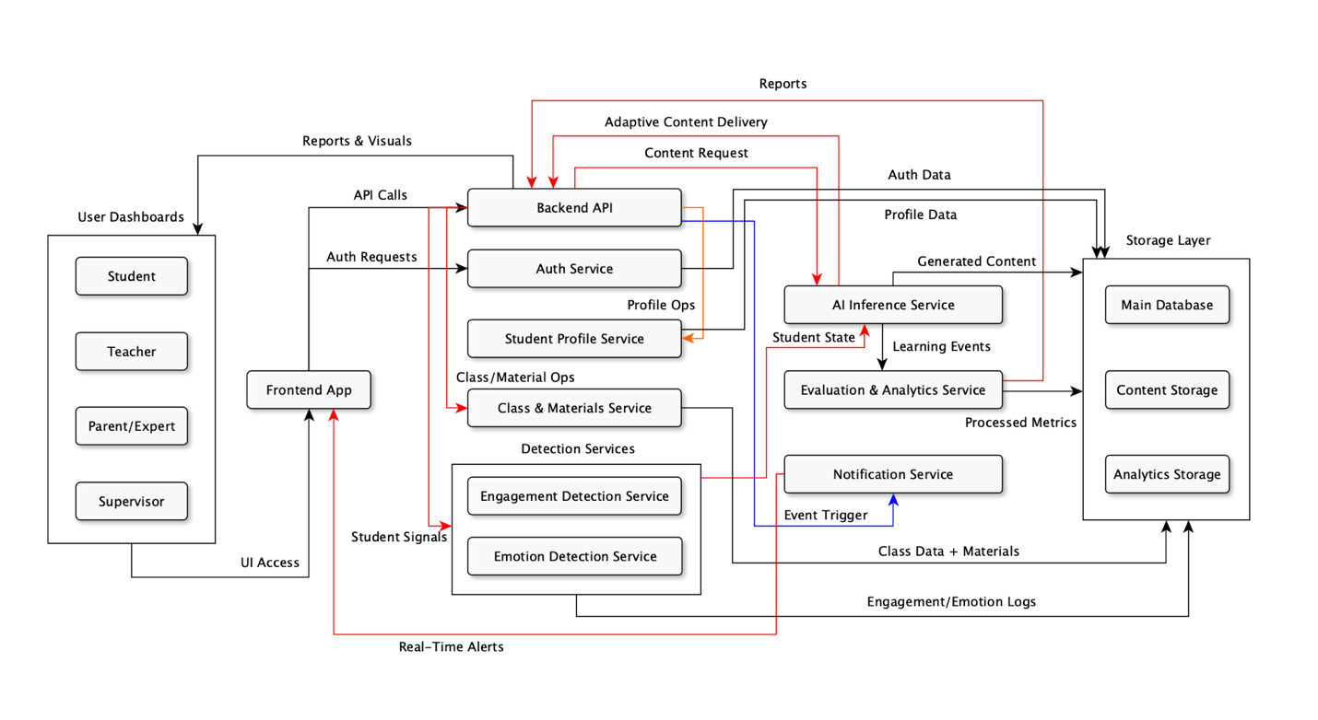
High-Level Architecture

1) Major system components
User Roles :
- Student
- Teacher
- Parent / Expert
- Supervisor
Frontend Layer :
- Frontend App (React)
Core Backend / Services :
- Backend API (FastAPI)
- Auth Service
- Student Profile Service
- Class & Materials Service
- Detection Services:
  - Engagement Detection Service
  - Emotion Detection Service
AI & Analytics :
- AI Inference Service
- Evaluation & Analytics Service
- Notification Service
Storage Layer :
- Main Database (PostgreSQL)
- Content Storage (object store / media)
- Analytics Storage (time-series / event logs)

2) Responsibilities

User Roles (Student / Teacher / Parent/Expert / Supervisor) :
- Interact with the system via the Frontend App (role-specific UIs).
- Trigger workflows: account creation, profile edits, class management, content consumption.
- Receive role-appropriate dashboards, alerts, and reports.

Frontend App (React) :
- Single entry point for all users; hosts dashboards and lesson interfaces.
- Calls backend APIs (HTTPS + JWT) and maintains WebSocket connections for live updates.
- Renders adaptive content, notifications, and input capture (answers, audio/video for monitoring).

Backend API (FastAPI) :
- Central orchestrator: exposes REST APIs, routes requests to services and storage.
- Enforces business logic (profiles, classes, gamification, session orchestration).
- Aggregates and routes data between Frontend, AI, Detection, Analytics, and Storage.

Auth Service :
- Handles signup / login, password management, role assignment.
- Issues and validates JWT tokens for stateless authentication and RBAC.
- Provides user identity info to Backend and services.

Student Profile Service :
- Stores and serves student persona data (demographics, preferences, learning-style).
- Exposes profile features for AI personalization and content tailoring.
- Tracks profile edits by teachers/parents and syncs to the main DB.

Class & Materials Service :
- Manages class definitions, milestones, schedules, and teacher uploads.
- Stores content metadata (links) and coordinates content retrieval.
- Provides endpoints for teachers to organize lessons and assign milestones.

Detection Services (Engagement & Emotion) :
- Capture and analyze student interaction streams (clicks, video/audio, activity).
- Produce normalized signals (engagement levels, affective state) and persist them.
- Stream real-time signals to AI and Analytics for adaptive decisions.

AI Inference Service :
- Generates educational content (explanations, quizzes, audio/video segments).
- Produces adaptive lesson plans and runtime adjustments based on student state.
- Consumes profile data, engagement/emotion signals, analytics and teacher/expert inputs.

Evaluation & Analytics Service :
- Processes raw event logs into metrics (mastery, progress, trends).
- Runs batch/near-real-time analytics and produces reports and signals for AI.
- Supplies dashboards and supervisor reports with aggregated insights.

Notification Service :
- Accepts event triggers and pushes real-time notifications via WebSocket / push.
- Delivers adaptive nudges, gamification messages, and important alerts to users.
- Can queue and throttle messages to avoid overload.

Main Database (PostgreSQL):
- Canonical store for users, classes, profiles, gamification points, and metadata.
- Supports transactional operations and relational queries via ORM (SQLModel).

Content Storage (object store / media):
- Stores large binary assets (videos, audio, images, generated content).
- Serves assets to frontend (CDN-friendly) and to AI for post-processing.

Analytics Storage (time-series / event logs):
- Stores time-series or event-stream data (engagement, emotions, raw interactions).
- Optimized for analytics queries used by evaluation service and AI retraining pipelines.

3) Communication protocols
- Frontend ↔ Backend API: HTTPS REST (JSON) + JWT for auth tokens.
- Frontend ↔ Notification Service: WebSocket or Push (real-time updates).
- Backend ↔ Auth Service: HTTPS REST (user auth, token introspection).
- Backend ↔ AI Inference Service: HTTPS REST (synchronous requests) or gRPC/WebSocket for lower-latency streaming if needed.
- Backend ↔ Detection Services: HTTPS REST for batch; WebSocket/streaming for live signals.
- Services ↔ Storage: SQL / ORM to Main DB; S3-like API for Content Storage; time-series API for Analytics Storage.
- Evaluation/Analytics ↔ Backend / Dashboards: HTTPS REST (report endpoints) and optionally message queues for heavy jobs.
- Inter-service auth: Mutual TLS or service tokens (recommended) for service-to-service calls.

4) Architecture summary:
The system is a modular, service-oriented architecture centered on a FastAPI Backend that orchestrates user flows, content management, personalization, and analytics. The React Frontend provides role-specific UIs (student, teacher, parent/expert, supervisor) and communicates with backend services over HTTPS using JWT-based authentication. Core backend services manage profiles, classes, content uploads, and detection pipelines; these services persist canonical data in PostgreSQL and media assets in a content store. An AI Inference Service consumes student profiles, engagement and emotion signals, evaluation results, and teacher/expert inputs to generate and adapt instructional content in real time. Evaluation and analytics services process logs into actionable metrics that feed dashboards and further refine AI personalization.

